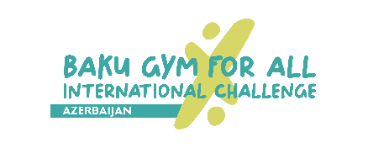
2nd Baku Gym For All International Challenge
1 & 2 JUNE, 2024
Competition schedule

June 1 / Saturday
08:00 – 09:00 | Workshops | Main stage (behind the Azerbaijan State Puppet Theatre), near Baku  Sports Palace, parking area of Baku Crystal Hall
09:00 – 09:30 | Transition of teams from the area of workshops to the main stage
09:30 – 13:30 | Official Rehearsals | Main stage (behind the Azerbaijan State Puppet Theatre)
17:00 – 17:15 | Marching in of the teams | From Baku  Sports Palace to the Azerbaijan State Puppet Theatre
17:15 – 17:30 | Opening Ceremony | Main stage (behind the Azerbaijan State Puppet Theatre)
17:30 – 21:00 | Performances in Gymnastics for All
21:00 – 21:15 | Interactions with spectators
21:15 – 21:45 | Award Ceremony
June 2 / Sunday
08:00 – 09:00 | Workshops | Main stage (behind the Azerbaijan State Puppet Theatre), near Baku  Sports Palace, parking area of Baku Crystal Hall
16:45 - 17:00 | Award Ceremony (Nominations) | Main stage (behind the Azerbaijan State Puppet Theatre)
17:00 – 19:00 | Gala-show

