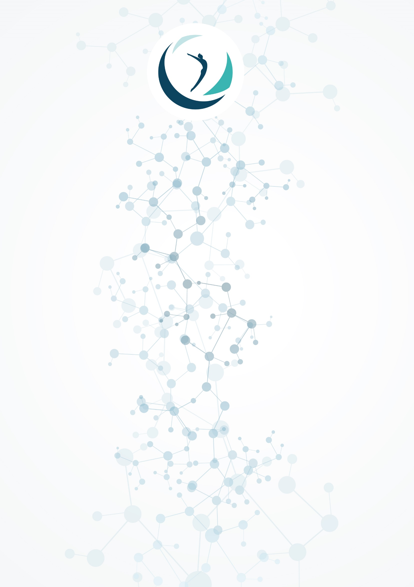**FIG TRAMPOLINE GYMNASTICS LOCAL ORGANIZING COMMITTEE**

**WORLD CUP / AGF TROPHY**

**BAKU, AZERBAIJAN**

**FEBRUARY 15 & 16, 2020**

***What are coronaviruses?***

Coronaviruses are a family of viruses that predominantly infect animals, but in some cases can be transmitted to humans. Usually, diseases caused by coronaviruses proceed in a mild form, without causing severe symptoms. However, there are severe forms, such as the Middle East Respiratory Syndrome (Mers) and Severe Acute Respiratory Syndrome (Sars).

***What are the symptoms of a disease caused by a new coronavirus?***

- Feeling tired

- Labored breathing

- Heat

- Cough and / or sore throat

Symptoms are largely similar to many respiratory diseases, often mimic the common cold, and may be like the flu.

If you have similar symptoms, consider the following:

Have you been to high-risk areas in the past two weeks?

Have you been in touch with someone who has been visiting high-risk areas in the past two weeks?

If the answer to these questions is positive, the symptoms should be treated as carefully as possible.

***How is coronavirus transmitted?***

Like other respiratory viruses, coronavirus spreads through the droplets that form when an infected person coughs or sneezes. In addition, it can spread when someone touches any contaminated surface, such as a door handle. People become infected when they touch their mouth, nose, or eyes with soiled hands.

***How to protect yourself from coronavirus infection?***

The most important thing you can do to protect yourself is to keep your hands and surfaces clean.

Keep your hands clean, wash them often with soap and water, or use a disinfectant.

Also try not to touch your mouth, nose or eyes with unwashed hands (usually such touches are unconsciously performed by us on average 15 times per hour).

Carry a hand sanitizer with you so that you can clean your hands in any environment.

Always wash your hands before eating.

Be especially careful when in crowded places, airports, and other public transportation systems. As much as possible, touch the surfaces and objects located in such places and do not touch your face.

Carry disposable wipes with you and always cover your nose and mouth when you cough or sneeze, and be sure to dispose of them after use.

Do not eat food (nuts, chips, cookies and other snacks) from common packages or utensils if other people dipped their fingers in them.



Avoid complimentary handshakes and kisses on the cheek until the epidemiological situation has stabilized.

At work, regularly clean surfaces and devices that you touch (computer keyboard, general office equipment panels, smartphone screen, remotes, door handles and handrails).

***How to wear a medical mask?***

1. Carefully cover your nose and mouth with a mask and secure it to reduce the gap between the face and mask.

2. Do not touch the mask during use. After touching a used mask, for example, wash your hands to remove it.

3. After the mask becomes wet or dirty, put on a new clean and dry mask.

4. Do not reuse disposable masks. They should be discarded after each use and disposed of immediately after removal.

***What is the difference between coronavirus and influenza virus?***

Coronavirus and influenza virus may have similar symptoms, but genetically they are completely different.

Influenza viruses multiply very quickly - symptoms appear two to three days after infection, and the coronavirus takes up to 14 days to do this.

***Preventive measures***

First and foremost, we invite you to check the basic protective measures issued by the World Health Organisation (WHO): <https://www.who.int/emergencies/diseases/novel-coronavirus-2019/advice-for-public>.

**RULE 1. WASH HANDS WITH SOAP**

Clean and disinfect surfaces using household detergents.

Hand hygiene is an important measure to prevent the spread of influenza and coronavirus infection. Washing with soap removes viruses. If it is not possible to wash your hands with soap, use alcohol-containing or disinfecting liquids and wipes.

Cleaning and regular disinfection of surfaces (tables, door handles, chairs, gadgets, etc.) removes viruses.

We strongly encourage you to check the recommendations of your own health authorities to find out what precautions to take when travelling and to share good practice with your athletes.

**RULE 2. FOLLOW DISTANCE AND ETIQUETTE**

Viruses are transmitted from a sick person to a healthy person by airborne droplets (by sneezing, coughing), so a distance of at least 1 meter from patients should be kept.

Avoid touching your eyes, nose, or mouth. Influenza virus and coronavirus spread through these pathways.



Wear a mask or use other improvised protective equipment to reduce the risk of infection.

When coughing, sneezing, cover your mouth and nose with disposable wipes, which should be discarded after use.

**RULE 3. LEAD A HEALTHY LIFESTYLE**

A healthy lifestyle increases the body's resistance to infection. Follow a healthy regimen, including proper sleep, consumption of foods rich in proteins, vitamins and minerals, and physical activity.

**RULE 4. PROTECT YOURSELF WITH THE MEDICAL MASK**

Wearing masks limited the spreading of the virus.

Medical masks for respiratory protection use:

- when visiting crowded places, traveling by public transport during the period of increasing incidence of acute respiratory viral infections;

- when caring for patients with acute respiratory viral infections;

- when communicating with persons with signs of acute respiratory viral infection;

- with the risks of infection by other infections transmitted by airborne droplets.

**RULE 5. WHAT TO DO IF ANYONE HAS VIRAL INFECTION?**

If you notice one or more of the following symptoms: -high body temperature, -chills, -headache, -weakness, -nasal congestion, -cough, -labored breathing, -muscle pain, -conjunctivitis (in some cases, there may be symptoms of a gastrointestinal upset: nausea, vomiting, diarrhea) you have to:

Call a doctor.

Allow the patient a separate room in the house (building). If this is not possible, keep a distance of at least 1 meter from the patient.

Minimize contact between the patient and loved ones, especially children, the elderly and those with chronic conditions.

Ventilate the room frequently.

Keep clean, wash and disinfect surfaces with household detergents as often as possible.

Wash your hands often with soap.

When caring for a patient, cover your mouth and nose with a mask or other protective equipment (scarf, scarf, etc.).

Only one person should look after the patient.